Bourne Issue Application Set Up

1. Add the application from the FIRM folder as “User-defined Command” from the “Settings”:

* C:\Users\user.name\Bourne Group\Bourne Steel - BG2021\Bourne Issue App\BourneIssueApp.exe

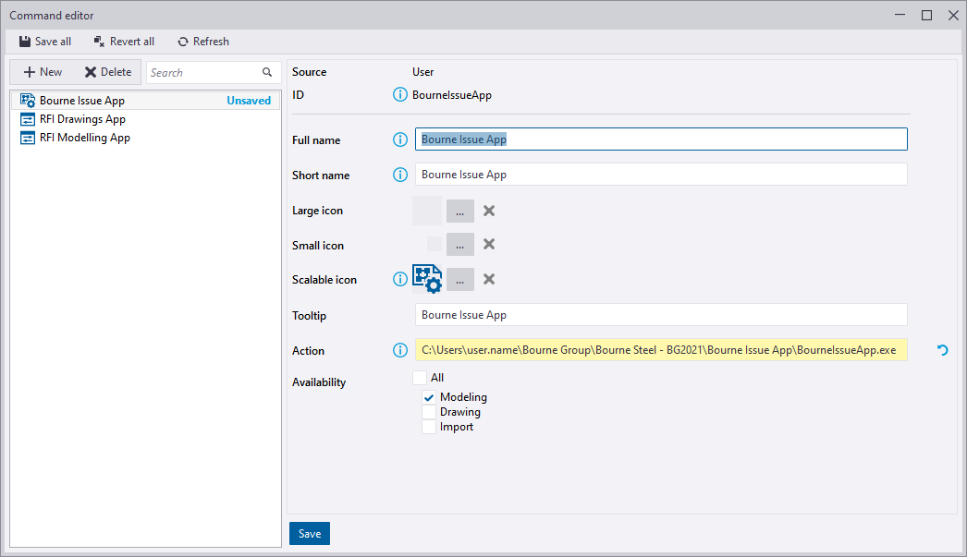

* Add the application as a button to the ribbon.

